APPLE SALES DASHBOARD – 2024

# Project Title:

Apple Sales Analysis Dashboard – 2024

# Problem Statement:

Apple operates in a highly competitive global market. The company deals in various products and services across multiple regions. To maintain its edge, Apple needs a comprehensive analysis of sales performance segmented by region, state, and product category. The primary challenge lies in identifying revenue drivers, underperforming regions, and understanding customer trends in a visually effective manner.

# Objective:

The key objectives of this project are:  
- To visualize Apple’s global sales distribution across different regions and states.  
- To analyze product-wise sales (iPhone, iPad, Mac, and Wearables).  
- To measure and compare the services revenue contribution across geographies.  
- To provide strategic insights into which areas and products drive the most revenue.

# Data Source:

The dataset used for this dashboard was sourced from an internal Apple sales record for the year 2024. The dataset includes:  
- Product-wise sales in million units  
- Services revenue in billion dollars  
- Sales distribution by region and state

# Scope of the Project:

The analysis covers six major geographic regions: Europe, Greater China, North America, Rest of Asia, and Rest of World.  
It includes state-level granularity for more localized insight.  
Products analyzed include: iPad, iPhone, Mac, and Wearables.  
Services revenue is analyzed by both region and state.

# Description of the Dashboard:

The Power BI dashboard includes the following key visualizations:

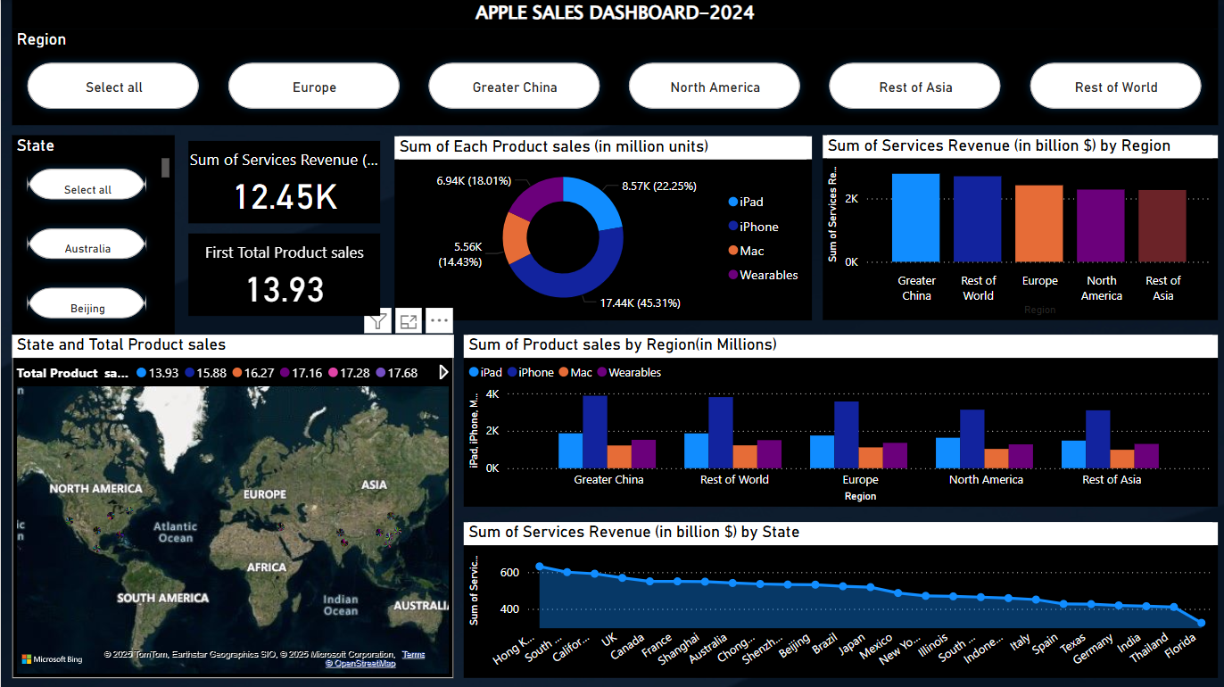

1. Filters (Top Panel):  
- Region & State Slicers: Allow users to filter data based on specific regions or states for focused analysis.

2. KPI Tiles:  
- Sum of Services Revenue: Displays total services revenue in ‘000s.  
- Total Product Sales: Shows the sum of all product sales in million units.

3. Donut Chart:  
- Displays the share of each product type in total product sales. iPhone leads with 45.31%, followed by iPad, Wearables, and Mac.

4. Bar Chart (Top Right):  
- Shows services revenue by region, highlighting that Greater China and Rest of World generate the highest service revenues.

5. Clustered Bar Chart (Center):  
- Compares product sales across regions, indicating high iPhone sales in all regions, especially Greater China and North America.

6. Line Chart (Bottom):  
- Displays services revenue by state, where Hong Kong, South Korea, and California are top contributors.

# 

# Conclusion:

This dashboard provides a comprehensive view of Apple’s sales performance in 2024. Key insights include:  
- iPhone dominates product sales with a 45% share.  
- Greater China is the leading region in both product sales and services revenue.  
- Certain states like Hong Kong and South Korea significantly outperform others in terms of services revenue.  
- The dashboard enables better decision-making by identifying top-performing regions and product categories.  
  
This analysis can help stakeholders align marketing, supply chain, and sales strategies to improve performance in underperforming areas and capitalize on strong markets.